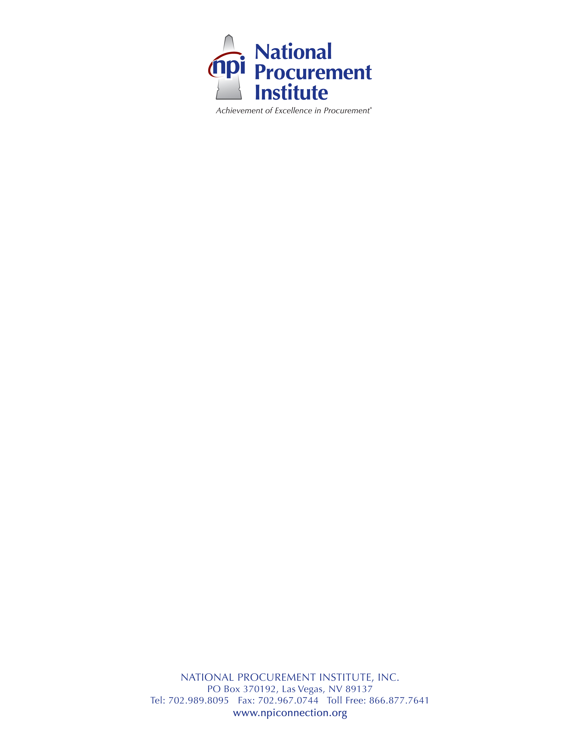

NOMINATION FOR THE
CARLTON N. PARKER AWARD FOR OUTSTANDING SERVICE
2016

SUBMITTAL DEADLINE: Friday, August 19, 2016
SUBMIT TO: pmarchell@lvcva.com

I. Nominee

Name: Job Title:
Employer Name:
Employer Address:
Employer Phone Number: Years in Public Purchasing/Supply Management:
Supervisor/Manager name, email, phone:

II. Detailed Information

- Nominee’s involvement and contributions to NPI

- Nominee’s involvement in promoting education, professional development, and promoting pubic purchasing and supply management

- Nominee’s active leadership in public purchasing and supply management organizations

- Nominee’s involvement with other levels of government in the advancement of public purchasing and supply management

- Nominee’s innovation in changing public purchasing and supply management procedures / laws

- Nominee’s high ethical and moral standards

Nominated By:

Name: Date:
E-mail: Phone:

